Title of the Paper [Arial Bold 16 pt]
Author1, Author2, Author3 [First name, surname; Times New Roman 13 pt]
Affiliations [Times New Roman 13 pt]
E-mail: author1@xxx.yy, author2@zzz.uuu.edu, author3@hhh.com [Times New Roman 13 pt]
Abstract [Style: Abstract & Acknowledgements, Arial Bold 13 pt]
When preparing the paper, please, write directly into the style sheet and replace the model text (please use always the correct style as indicated in the style sheet). Please do not insert any blank lines between the different sections of the paper (line spaces are predefined in the style sheet). – Each paper must include an abstract of 150 to 200 words in Times New Roman 12 pt with single line spacing. The abstract must be written in the same language as the main text of the paper (i.e. English abstract, English paper). Please do not repeat the abstract in the main text of the paper, e.g. as part of the introduction. The heading Abstract should be aligned left, in Arial Bold 13 pt.
Keywords: give at least three keywords separated by semicolons; you can reuse the keywords already used when you submitted the first version of the paper via the EasyChair; do not end the keyword list with a full stop.

Format [Style: Level 1 Heading, Arial Bold 14 pt]
Apart from headings, author information and captions, the text should be fully justified. The font for the main body of the text should be Times New Roman 12 pt, single line spacing. Left, right, and bottom margins should be 2 cm and the top margin 2.5 cm.
Only block paragraphs should be used; do not indent the first line of paragraphs.

General Instructions
Full papers should be in the range of a minimum of eight and a maximum of twelve pages while short papers should be between a minimum of six and a maximum of eight pages long. The size of papers based on posters and software demonstrations is expected to be between a minimum of four and a maximum of six pages, including figures and references.
Each paper should be submitted both as doc. or docx. file and as an unprotected PDF file via the Congress e-mail: euralex2016@tsu.ge. While submitting the paper, indicate the type of contribution (full paper, short paper, poster, software demo). As a file naming convention please use the following structure: number of the paper, given by the EasyChair; SurnameAuthor1, SurnameAuthor2, first two or three words of the title (don’t use more than 2 author names).

Page Numbering
Please do not include page numbers in your paper. The definitive page numbering of papers published in the proceedings will be decided by the organizing committee of EURALEX 2016.

Headings/Level 1 Headings [Style: Level 1 Heading]
All headings, including the main title, should be capitalized according to the following rules: use upper case for the first word as well as for content words and lower case for function words (e.g. The Title of the Paper). Headings are aligned left. Type level 1 headings in Arial Bold 14 pt. There should also be a space of 12 pt between the heading and the preceding section, and a space of 3 pt between the heading and the text following it. Use Arabic Numerals for each heading and subheading (apart from paper title, abstract and acknowledgements); do not use a full stop after the last numeral (e.g. 4, 4.1, 4.1.1). Do not end a title or heading with a full stop.

Headings/Level 2 Headings [Style: Level 2 Heading, Arial Bold 13 pt]
The format for level 2 headings is basically the same as for level 1 headings, except that the font is Arial Bold 13 pt. Level 2 headings must be numbered accordingly (e.g. 1.1, 1.2). Use headings and subheadings up to a maximum of three levels.

Headings/Level 2 Headings
Please note that there must always be at least two level 2 and level 3 headings if you need to use these in your paper (e.g. at least 4.1 and 4.2 ).

Headings/Level 3 Headings [Style: Level 3 Heading, Arial Bold 12 pt]
The format for level 3 headings is the same as for level 2 headings, except that the font is Arial Bold 12 pt.

References in the text
All references within the text should be placed in parentheses containing the author's surname followed by the date of publication (Verlinde 2009). If the sentence already includes the author's name, then it is only necessary to put the date in parentheses: Verlinde (2009). When citing several authors, use a semicolon to separate the references: (Verlinde 2009; Atkins & Rundell 2008). For citing page numbers use the following format: (Rundell 2012: 49) or (Rundell 2012: 49-51). When the reference has more than three authors, only cite the name of the first author followed by et al.

Citations
Short citations up to 1-2 lines are embedded in the main body of the text using quotation marks: “Metalexicography is a broad discipline […]” (Rundell 2012: 49). Longer citations should form a separate paragraph; use Times New Roman 11 pt, single line spacing, and spaces of 6 pt before and
6 pt after the citation. Do not use quotation marks; the reference must be put at the end of the citation without any punctuation mark following it:
Metalexicography is a broad discipline, taking in subjects such as dictionary criticism, dictionary typology, the history of lexicography, and the description of dictionary microstructures. These are all valid areas of study. The question for practising lexicographers is how far [my italics] any of this impacts on how they do their jobs or helps them to produce better dictionaries. (Rundell 2012: 49)
Use double quotation marks for short citations but also for terms and expressions that are used in a special sense (occasional meaning), e.g. a “harmless drudgery”. For quotations within quotations use single quotation marks, e.g. “[...] ‘harmless drudgery’ […]”. Omissions should be signalled with three dots within square brackets: […]. Square brackets are also used to signal remarks by the author (see citation example above: [my italics]).

Emphasis and Foreign Words
Use italics for foreign language and emphasis. Please refrain from the use of FULL CAPS, bold type and underlining.

Figures and Tables

Figures
All figures should be centred and clearly readable. Colour figures are allowed. Figures should be supplied in a clean and high quality format, using, if possible, a resolution of a minimum of 300 dpi. Figures should be numbered; place captions in Times New Roman 11 pt beneath the figure. Spacing of captions should be set at 6 pt before and 6 pt after. End each caption with a full stop.
Example:
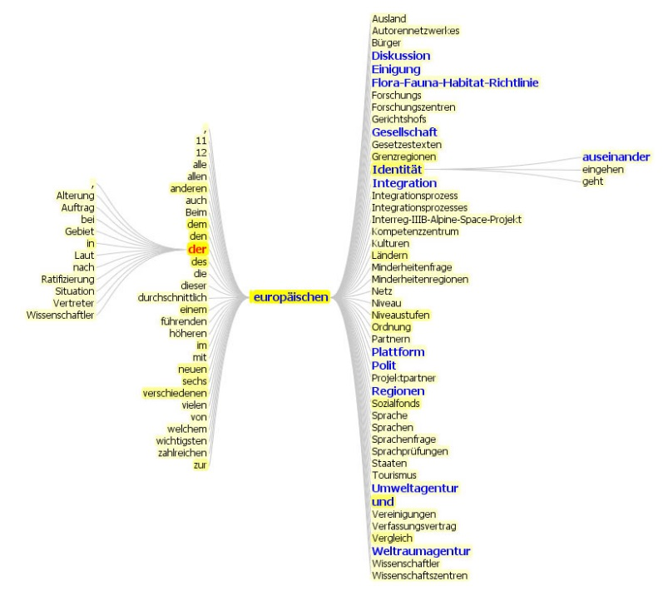
Figure 1: Caption.
Figure and caption should always appear together on the same page.

Tables
The instructions for tables are the same as for figures (see previous section). Number tables and figures consecutively (Figure 1, Figure 2, etc., Table 1, Table 2, etc.).
Example:
headword | corpus
wordclass | noun
domain label | linguistics
Table 1: Caption.
Each table and figure has to be referred to in the main text (see table 1).

Footnote
Footnotes are indicated in the text by a number in superscript. Please note that superscript numerals follow punctuation marks.

Examples & Lists
All examples should be numbered progressively (do not start again in each section); put the numbers in round brackets and do not indent them; use Times New Roman 12 pt and spacing of 6 pt before and 6 pt after the example(s); e.g.
(50) Man kann nicht alle Jugendlichen in einem Topf werfen.
(51) Jedoch stellt sich die Frage, kann man wirklich alle Jugendlichen in einen Topf stecken?
Items in lists should be preceded by a dot; the dots are not intended; the text after the dot is hanging at 1.1 cm; otherwise the same rules apply as in the formatting of examples; e.g.:
- orthography
- grammar

Conclusion
The EURALEX 2016 proceedings are published by the Lexicographic Centre at Ivane Javakhishvili Tbilisi State University.
We remind you that it is in the author’s responsibility to obtain any permission required for the use of material owned by others.

References
Bibliographical references should be listed in alphabetical order at the end of the paper. The title of the section, References, should be a level 1 heading. The first line of each bibliographical reference is not indented whereas the rest of the entry should be indented by 0.50 cm.

For citation standard see http://www.prevajalstvo.net/pravilnik-za-citiranje-prev
Acknowledgements (optional) [Style: Abstract & Acknowledgements]
Place all acknowledgements (including those concerning research grants and funding) in a separate section after the reference section. The format used for the acknowledgements is the same as for the abstract.
Appendix (optional) [Style: Abstract & Acknowledgements]
Place all appendices in a separate section at the end of the paper. The format used for this section is the same as for the abstract. If you use more than one Appendix multiply the section using the following heading names: Appendix 1 , Appendix 2, etc.

They should be in Times New Roman 11 pt, and appear at the bottom of the same page as their corresponding number. Footnotes should also be separated from the rest of the text by a horizontal line of 5 cm.

